Name | Sarah Hahne
Test date | 12/17/2008
Computer OS | WinXP Professional SP3
Computer browser version  (Only IE 7.0, Firefox 2.x, and Firefox 3.x are supported) | IE7
Program | caAERS
Program Version | 1.6
Program URL | https://152.11.189.189:8443/caaers/pages/task

- I did a search for patient 9730101 and was directed to the ‘enter subject’ screen. It would be helpful to be able to view patients previously entered in the search screen. When I clicked ‘continue’ I was hoping to see more information about the subject instead of enter more information. I understand that clicking the plus icon next to “Medical History” gives you more information, but my initial instinct was to click ‘continue.’

- When entering a patient’s medical history, could the ‘add’ button be replaced with ‘add’ and ‘save’ buttons? I had to enter the disease questions 3 times before the information saved. I entered met disease site, pre-existing, conmeds and prior therapy answers and then clicked continue assuming that my answers were saved only to find them missing on review. I thought that the ‘add’ button was existed to add additional disease sites, pre-existing, conmeds and prior therapies.

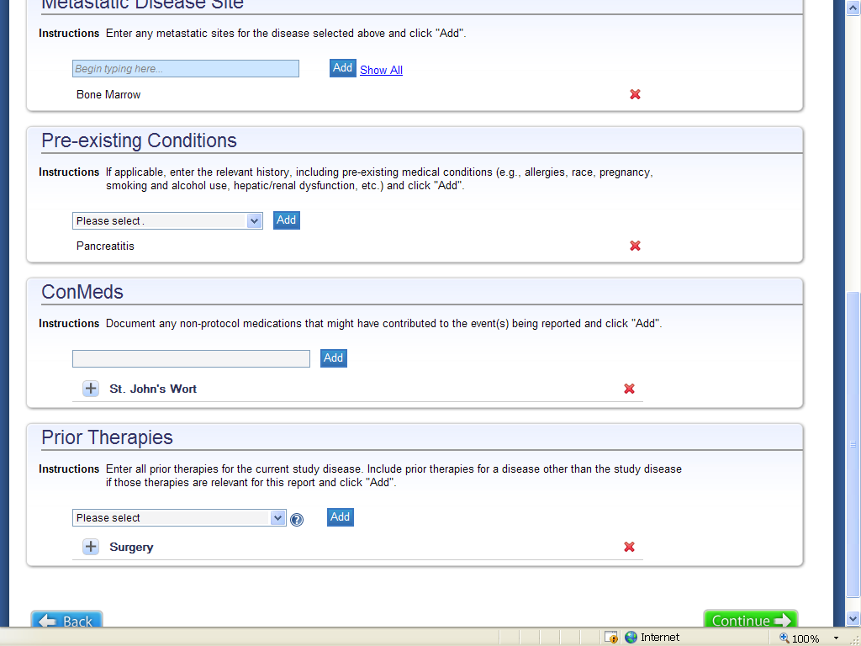

- After searching for a subject and clicking continue on the review page, I get this error message. This information has already been entered when the patient was initially put into the system. Why is it asking about this again?
- 